Notate possible tools and what they do. Also add links to the tool so the team can also read into the tools.

Aleksandar - This is what I found, it is a good article

<https://www.guru99.com/how-to-hack-web-server.html>

I also found these videos about MetaSploit [MetaSploit tutorial for beginners](https://www.youtube.com/watch?v=cnkLv_RE3EI)

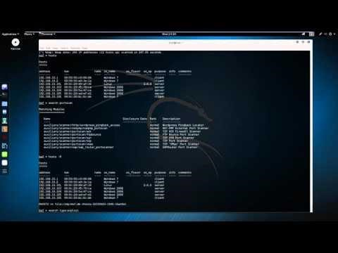

[Complete Metasploit System Hacking Tutorial!](https://www.youtube.com/watch?v=_C7nRJ6WsmI)



Brandon – Possible tools Nmap to scan for open ports

John the Ripper – to try to brute force attack the password to the root user.

Hydra through Kali Linux – attaching webpage that shows how we can attempt to login through root user with Hydra.

<https://www.kali.org/tools/hydra/>